# CS 255 System Design Document Template

This template lays out all the different sections that you need to complete for Project Two. Each section has guidance to prompt your thinking. You will need to continually reference the interview transcript as you work to make sure that you are addressing your client’s needs. There is no required length for the final document. Instead the goal is to complete each section based on what your client’s needs are. Remove this note when you are finished, and replace all bracketed text with the relevant information.

## UML Diagrams

### UML Use Case Diagram

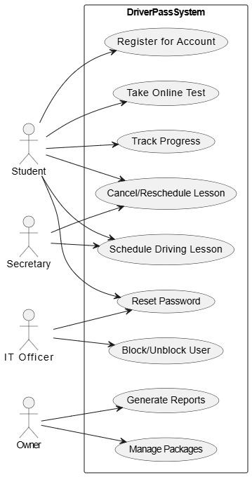

### UML Activity Diagrams

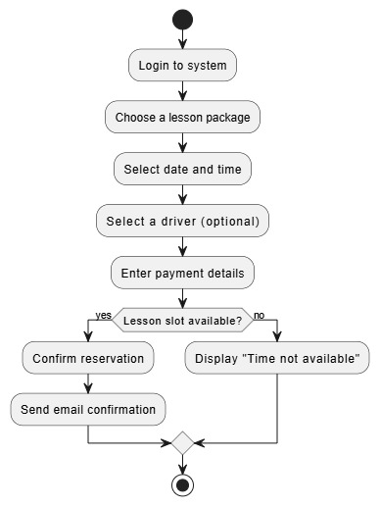

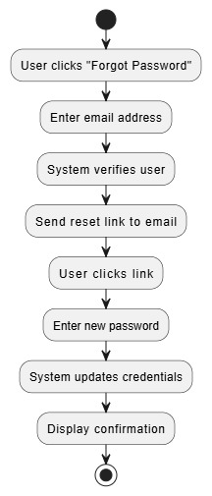

### UML Sequence Diagram

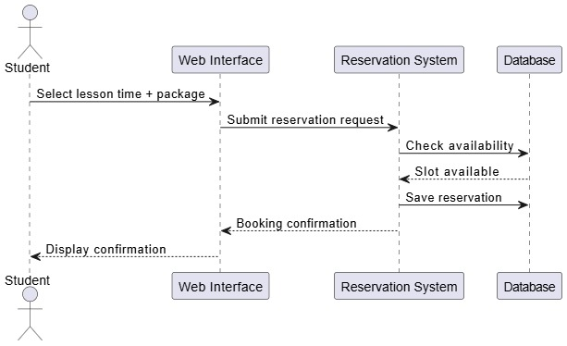

### UML Class Diagram

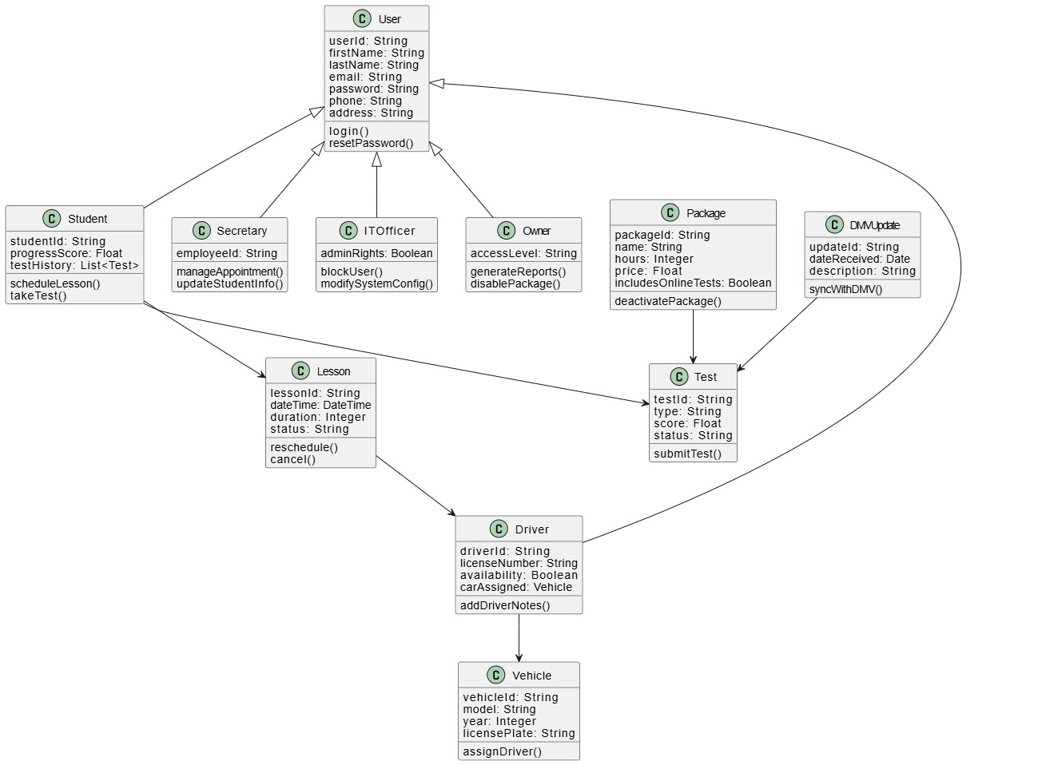

## Technical Requirements

Cloud Infrastructure: Utilize cloud-based servers such as AWS or Azure for hosting.

Responsive Frontend: Develop a frontend interface compatible with mobile devices and tablets.

Data Security: Implement secure storage solutions for both user and lesson-related data.

Web Application Framework: Employ a robust framework like Django (Python) or Node.js (JavaScript) for backend development.

Frontend Technologies: Use standard web technologies—HTML, CSS, and JavaScript—for building the user interface.

Database Management: Choose either PostgreSQL or MySQL as the primary relational database system.

Cloud Storage: Store files and assets using AWS S3.

Modeling Tools: Use Lucidchart for system modeling and diagramming.

Version Control: Maintain codebase integrity with GitHub.

Security Measures: Enforce HTTPS and implement role-based access control to safeguard user information.

API Integration: Integrate with the DMV API to ensure timely updates for test content.